# A Deep Dive into DeFi Portfolio Management & Allocation

Decentralised finance (DeFi) provided a unique backdrop to my most recent exploration: portfolio management and allocation strategies for the blockchain era. This month-long project allowed me to delve into the intricacies of DeFi, formulating algorithms designed to balance the scale of risk and returns in an environment renowned for its volatility.

These algorithms emerged from the fusion of traditional financial principles with the fast-paced, complex DeFi realm. But implementing them was only the start — it was crucial to test their resilience under various market conditions. Hence, I resorted to backtesting, a method that involves applying the algorithms to historical data, thereby offering valuable insights into their potential performance.

## Understanding the problem



At the core of every investment strategy lies a portfolio — a collection of assets combined to maximise returns in line with an acceptable level of risk. Every portfolio is defined by its assets, but beyond that static characteristic, there lies a world of dynamic and interdependent variables: the weightage of the assets in the portfolio, the monetary value of these assets and hence, the portfolio's total worth, and the potential returns and risks that these assets entail.

In traditional markets, these characteristics can be reasonably predictable, offering investors a somewhat stable environment that they can use to devise their strategies. However, in DeFi, the challenge magnifies. The volatility of the ecosystem implies dynamic, often unpredictable shifts in potential returns and risk-profiles of individual assets — primarily influenced by rapid changes in liquidity provisions, protocol updates, and market sentiment.

This poses the central problem that every DeFi investor faces: how to construct a portfolio that optimises returns based on the level of risk willing to be assumed? The complexity of this task situates it in the realm of optimisation problems — a category renowned for the difficulty of its challenges, requiring sophisticated mathematical models and economic theories for resolution.

Over time, numerous solutions have been proposed to tackle this thorny issue, with mean-variance optimisation and risk parity being notable examples. These methodologies attempt to address the primary aspects of the issue, balancing the potential return of a portfolio with its inherent risk.

Given the abundance of such schemes, one of my first objectives was to implement all prominent strategies in Python using libraries such as pypfopt. The goal was to bring these traditional methods to the nuanced DeFi environment, allowing each strategy to be tested and evaluated accurately against the backdrop of the DeFi landscape. The results, fascinating as they are, provide a stepping stone towards creating a more comprehensive and effective DeFi portfolio management strategy.

## Backtesting

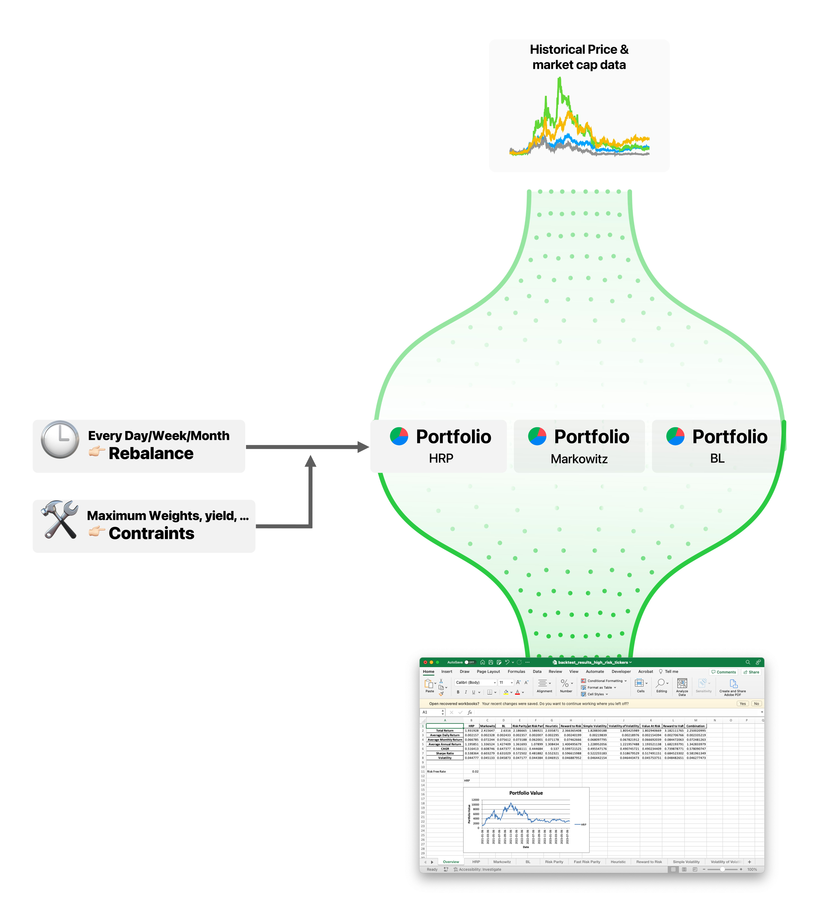

With the portfolio allocation strategies duly implemented through Python and the pypfopt library, the stage was set for comprehensive backtesting. This rigorous process is vital, serving as a litmus test for the performance of these strategies within the context of the DeFi landscape.

The backtesting strategy adopted in this project was conducted across three different rebalancing timelines: monthly, weekly, and daily. To introduce an extra layer of complexity and realism, constraints were also applied, challenging the efficacy of these portfolio allocation strategies under more restrictive conditions.

Each rebalancing operation involved pulling the latest 120 days of data, and modifying the portfolio in light of the chosen strategy. The decision to rebalance a particular asset was not taken lightly. Instead, the current holdings were meticulously evaluated to establish whether the proposed alteration was significant enough to warrant a rebalancing action.

The outcomes of this simulation were carefully recorded and compiled into an informative Excel document. The document distills the essence of the backtesting process, providing detailed insights into each strategy's performance across the rebalancing timelines and under the specific constraints.

Conducting the backtesting across three asset categories characterised by varying risk profiles (high-risk infrastructure/layer 1 assets, medium-risk ERC-20 tokens, and low-risk stable coins) added another layer of complexity to the process. It allowed for a much clearer understanding of how these strategies perform under diverse market conditions, thereby providing a comprehensive and nuanced picture of their efficacy.

This time-consuming and complex process ultimately serves the fundamental purpose of my project: to find the optimal path between risk and reward in the exciting world of DeFi portfolio management.